Guidelines for Preparation of a Manuscript (keynote paper) for the 9th All India Students’ Conference on Science and Spiritual Quest, 30 October - 1 November 2015, IIT Kharagpur
[Title Case, Arial 14 point, line spacing 16 points, concise and informative, avoid abbreviations, leave two blank lines below]

Sudipto Ghosh * [author name is Arial 10 pt and bold]
Department of Metals and Metallurgical Engineering, IIT Kharagpur, India [Affiliation is Arial 10 pt, italic, leave one blank line below]

P.K. Singh [if there is a co-author]
Department of Civil Engineering, IIT BHU, Varanasi, India
[leave three blank lines below]

ABSTRACT [[Abstract is left aligned. Leave 3 blank lines above and 1 blank line below –with single line spacing, i.e., line spacing is 12 pt, Caption, ABSTRACT is 11 pt, Length of the abstract must be limited to 200 words.]

Use Arial 10 pt for text and line spacing is 14 pt. (Exactly) for the whole manuscript. Do not give indent to Abstract. A self-contained abstract in a single paragraph outlining the scope and conclusions of the paper has to be limited to 200 words. Place the text in a single column throughout the manuscript.

1. Heading First Level [Title Case with Arial Font 11 pt in Bold, Leave 2 blank lines above and 1 blank line below – with a single line spacing. In the prescribed format, including all contents, the manuscript has to be within 15 pages]

This is the text formatting style. Leave two blank lines before and one blank line after the heading and follow this throughout the manuscript except for third level heading. Give indentation of 0.32” for first line of every paragraph for all headings. Please note that, there is only one line space between sentences but not two and, also there is no blank line between the paragraphs and that the paragraphs are indented. Make sure that your text does not exceed the specified margin in all sides of the page (page layout is: A4: Width 8.27”, Height: 11.69”, Top Margin: 2.08”, Left Margin: 1.81”, Right Margin: 1.39” and Bottom Margin: 1.88”, Orientation: Portait). In MS Word, these can be set as: Go to the toolbar → Page Layout → Margins → Custom Margins.
Obviously, this text and any guide bars will need to be deleted before you submit your manuscript [1].
Author et al. [1] suggetsed that please check your document for typographical errors and mistakes in spelling and grammar. The “spell check” option in the word processing software can be used to aid in performing this task. Use US Spell Check
Do not change any of the font styles or sizes used on this page.

1.1 Heading second level [Sentence case with Arial font size 10 in italic, leave one blank line above and one blank line below]

This is the text formatting style. Leave one line after the heading.
1.1.1 Heading third level [Sentence case with Arial font size 10 in italic]
This is the text formatting style. Do not leave any space after the heading.

2. Graphics and Tables [this is again a first level heading, Title Case with Arial Font 11 pt in Bold, Leave 2 blank lines above and 1 blank line below – with a single line spacing]

Graphics and Tables must be numbered consecutively and captioned. They must be clear and should be placed in the text immediately after the first reference to the figure or table. They must be separated from the text by a single line. All tables and figures must be center-aligned [2-4] and texts should not flow on its sides.
A Sample figure is shown in Fig. 1. While citing a figure, for example figure 1 below in the text, it should be cited as Fig. 1. The figure must be placed in the centered text box /table which should be invisible. The Figure caption must be formatted as 10 pt Arial, sentence case and centered below the graphic. The size of the invisible text box should be within the margins of the page.

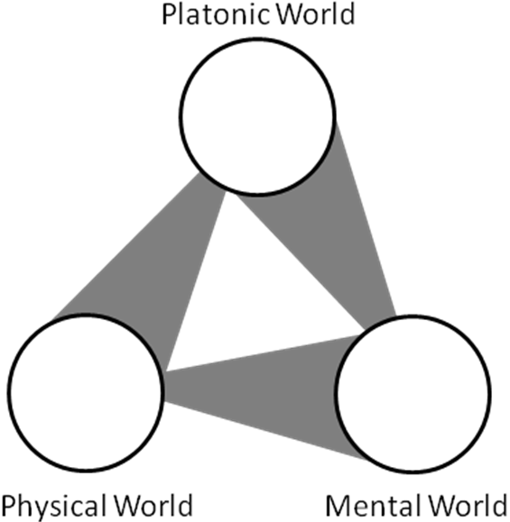
Fig. 1. The three worlds of Penrose and three deep mysteries connecting them. [Figure caption must be formatted as 10 pt Arial, sentence case and justified below the figure. Leave 1 blank line above and 1 blank line below the figure caption with a single line spacing. Figure along with its caption must stay together on the same page].

A sample table is provided in Table 1. Table caption must be formatted as 10 pt Arial, sentence case and justified above the table.

Table 1 [Table caption in the next para]
One line appears between the table title and the actual table. Two lines appear between the final line of the table and continuation of the narrative. The text in the table will be of 10 pt Arial. [Leave 1 blank line above and 1 blank line below – with a single line spacing]. Table along with its caption must stay together on the same page.
Sr. No. | Page Borders for AISSQ-2014 manuscripts*
1. | Top = 2.08” for all pages
2. | Bottom = 1.88"
3. | Left = 1.81"
4. | Right = 1.39"
5. | Header = 0.97” from edge
6. | Footer = 1.67" from edge

3. Text Boxes

Create the text boxes having maximum width of half of the running text column width with maximum of 5 lines. The font size of the text in the text box will be of 12 pt. Arial, Italics. The main idea in creating these text boxes is to highlight the main quotations and important points appearing in the manuscript. Place these text boxes near to the place of original text. Layout of the text box should be in tight with the main text. Example can be seen. To catch the attention of the readers, from the Sections on Introduction to Conclusions, put one text box on every page. The text boxes should always be right-aligned, like the one shown.
“The main idea in creating these text boxes is to highlight the main quotations and important points appearing in the manuscript.”
The “readability” and overall quality of presentation of your manuscript is in your hand. Please take care to prepare a high-quality manuscript to win the prize. It is strongly suggested that you have a colleague read your manuscript before submitting it. Your manuscript is required to be exactly in the format and to be sent by email to the Conference Chairman: scm.aissq@gmail.com.
Do not change the page borders. Do not adjust the line spacing from this example.

Acknowledgements [Arial 10 pt, Leave 1 blank line above and 1 blank line below – with a single line spacing]
After the conclusions and before the references, put acknowledgements in a separate section to list those individuals who provided you help (e.g., providing language help, writing assistance or proof reading the article, etc.) in preparation of the manuscript.

References [this is again a first level heading, do not give any level to this. Arial Font 11 pt in Bold, Leave 2 blank lines above and 1 blank line below – with a single line spacing]

Include the list of all publications cited in the text in references section following the text of the manuscript. In the text make references using a number in square brackets on the line (e.g. "Since Ghosh [1] has shown?") and the full reference should be given in a numerical list at the end of the paper.
References should be styled and punctuated according to the following examples: journal article [1]; journal supplement [2]; book [3]; edited book [4], thesis [5]; unpublished report [6]; published report [7]; proceedings [8], patent [9], web references [10].

- S. Ghosh, P.K. Singh, Title of the article, Journal Name, 41 (11) (2008) 1499-1511.
- S. Ghosh, P.K. Singh, Title of the article, Journal Name, 41 (suppl. 11) (2007) 1499-1511.
- S. Ghosh, Title of the Text Book, second ed., Springer, New York, 2009, pp. 62-75.
- P.K. Singh, Title of the chapter, in: S.C. Mishra, S. Ghosh (Eds.), Title of the Edited Book, McGraw-Hill, New York, 2008, pp. 1.21-1.55.
- R. Repaka, Title of the thesis, PhD thesis, Indian Institute of Technology, Kharagpur, India, 2008.
- P.K. Singh, Title of the unpublished report, ABCD Phase-I Report, ABC1-12345, Organisation Name, Location, Country, August 1989.
- P.K. Singh, Title of the published report, ABCD, India, 2008, pp. 1-8.
- A.B. Author, Title of the article, in: S.C. Mishra (Ed.), Proceedings of the Fourth All India Students’ Conference on Science and Spiritual Quest, Bhaktivedanta Institute, Kolkata, India, 2008, pp. 23-40.
- A.B. Author, Indian Patent No. 123456, year.
- Web references: As a minimum, the full URL should be given. Any further information, if known (DOI, author names, dates, reference to a source publication, etc.), should also be given.

About the Author(s)

At the end of paper, in running texts, provide a brief resume of the author(s). The top-left corner should contain the passport size photo (like the one we put for a VISA) (size: Height: 1.39” X Width: 1.19 “) of the author and texts should flow on the right of the photo and below it. Put a better quality print, provide a high-resolution photograph. Including this page, the total number of pages is limited to 6.

* Corresponding Author [add e-mail id of the corresponding author here]

